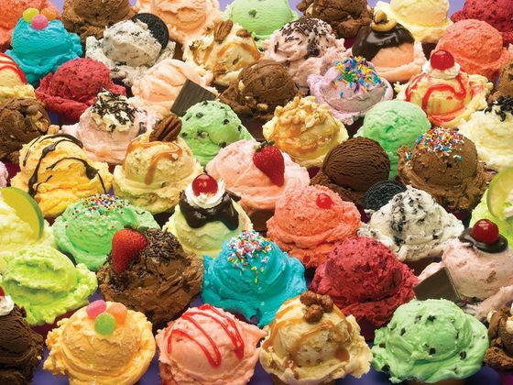

Which Ice Cream Flavor are you?